**Specification Document**

Team Name- Parallax Date- 19 Sep. 2023

**Introduction**

**Project purpose:** The purpose of this document is to outline the requirements and specifications for the development of a web or mobile application that assists users in planning their daily activities, setting reminders, prioritizing tasks, and tracking their progress. The Day Planner application aims to streamline users' daily routines and enhance their productivity.

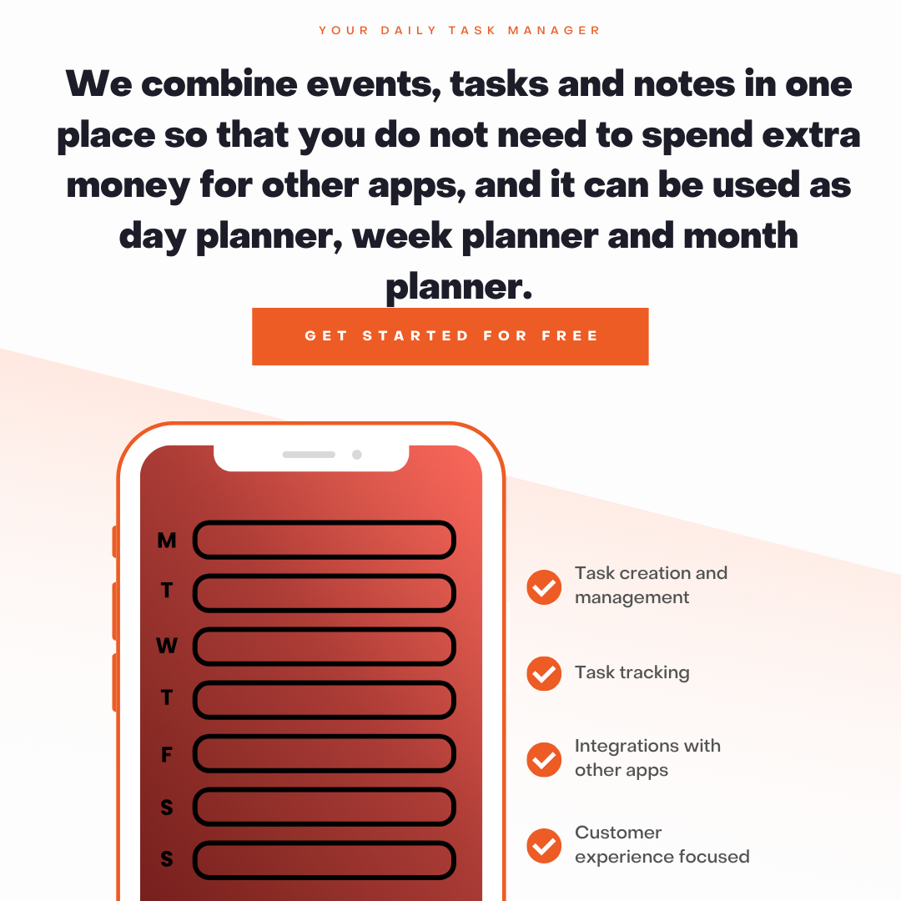

**Project Scope:**

* Registration and login for single user and team collaboration.
* Task Adding- User can add Personal, work miscellaneous tasks in list.
* Adding notes and links to tasks for revision.
* Adding progress bar to track progress.
* Interface for Tasks- All task, weekly task and daily task.
* Calendar integration for meeting and day planning.
* Adding weather forecasts for planning outdoor activities.
* Prioritizing tasks.
* Searching and filtering out tasks.
* Adding Recurring tasks like bill payment.
* Reminder through notification and emails.
* Adding Team space for collaboration.
* Tracking for daily expanses.
* Integrating Gmail.
* Colour themes and labels.

**A sample daily routine for using a day planner:**

1. In the morning, take a few minutes to review your planner for the day. This will help you get a sense of what you need to accomplish and how much time you have available.
2. Start by working on your most important and urgent tasks. If you have a lot of tasks to complete, break them down into smaller, more manageable steps.
3. Take breaks throughout the day to avoid burnout. Get up and move around, or take a few minutes to relax and clear your head.
4. At the end of the day, review your planner to see what you accomplished and what tasks still need to be completed. If you didn't get everything done, don't beat yourself up. Just pick up where you left off the next day.

**Tracking progress**

* Tracking your progress can help you stay motivated and on track. There are a few different ways to track your progress.
* You can simply check off tasks as you complete them. This is a simple and effective way to track your progress, but it may not be enough if you're working on complex or long-term projects.
* You can also use a more detailed tracking system, such as a Gantt chart or a Kanban board. These systems can help you visualize your progress and identify any potential roadblocks.
* No matter which tracking system you use, be sure to review your progress regularly. This will help you stay on track and make adjustments as needed.

**Prioritizing tasks**

* Not all tasks are created equal. Some tasks are more important and urgent than others. When prioritizing your tasks, consider the following factors:
* Importance: How important is the task to your overall goals?
* Urgency: How soon does the task need to be completed?
* Effort: How much time and effort will it take to complete the task?
* Once you've considered these factors, prioritize your tasks accordingly. The most important and urgent tasks should be at the top of your list.
* It's also important to be realistic about how much time you have available. Don't try to do too much in one day, or you'll end up feeling overwhelmed and stressed.

User Actions:

